BIG MART SALES PREDICTION

Team Name: Team Surya
Project:Big Mart Sales Prediction
Team members:
- K V N Surya Teja (Team Lead)
- G Tejesh
- G John
- A Bhagyaraju
GITHUB:
https://github.com/Sur2004/-K V N Surya Teja
https://github.com/tejesh-gorajana -G Tejesh
https://github.com/johngouri8-sudo/ -G John
https://github.com/BhagiKarthik/ -A Bhagyaraju
https://github.com/Sur2004/Big-Mart-Sales-Prediction -Common repository

Problem Statement:
Big Mart wants to understand the factors that affect the sales of its products in different outlets. The aim of this project is to analyze the historical sales data and predict Item_Outlet_Sales using a machine learning model.
Data Inspection:
Dataset Structure
The dataset contains:
- 8,523 records
- 12 columns
- 5 numerical columns
- 7 categorical/text columns
- 1 target column – Item_Outlet_Sales
The columns are:
Item Identifier, Item Weight, Item Fat Content, Item Visibility, Item Type, Item MRP, Outlet Identifier, Outlet Establishment Year, Outlet Size, Outlet Location Type, Outlet Type and Item Outlet Sales.
Item_Outlet_Sales is the value we want to predict. The dataset was loaded directly from KaggleHub using yasserh/bigmartsalesdataset.
Data Statistics:
- Item Weight – average: 12.86
- Item Visibility – average: 0.066
- Item MRP – average: 140.99
- Item Outlet Sales – average: 2,181.29
- Item Outlet Sales – median: 1,794.33
- Item Outlet Sales – minimum: 33.29
- Item Outlet Sales – maximum: 13,086.97

Data Cleaning
Missing values were found in Item Weight and Outlet Size. Item Weight was filled using the median, while Outlet Size was filled using the most common value within Outlet Type. Duplicate rows were also checked.
Data Visualization:
The analysis mainly focuses on:
- Missing values
- Sales distribution
- Outlet type and sales
- Correlations among numerical features
- Actual sales and predicted sales
- Feature importance
1. Missing Values
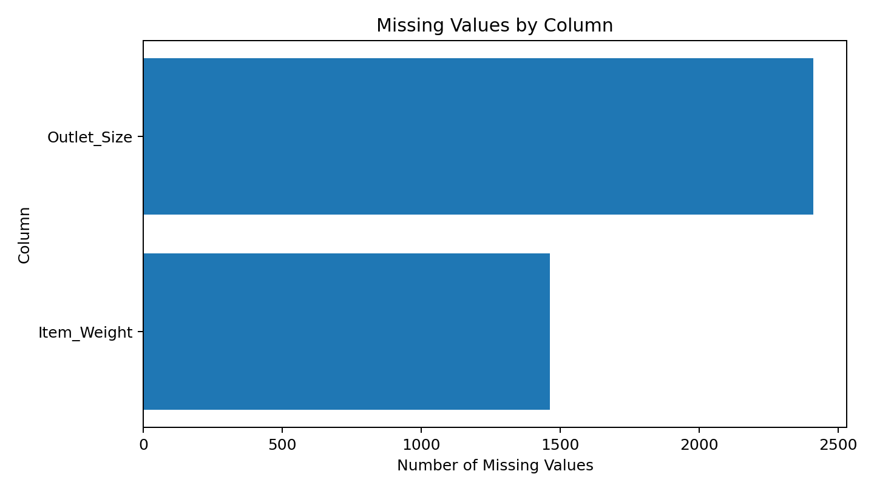
We first checked missing values because incomplete data can affect the model. The graph shows that Item Weight and Outlet Size contain missing values.
Key finding: Outlet Size has more missing values than Item Weight, so both columns need treatment before modeling.
2. Distribution of Item Outlet Sales
The sales distribution was checked to understand how the target values are spread. The mean sales value is higher than the median, which shows that some observations have comparatively high sales.
Key finding: Sales are not evenly distributed, so understanding the spread of the target is important before prediction.
3. Average Sales by Outlet Type
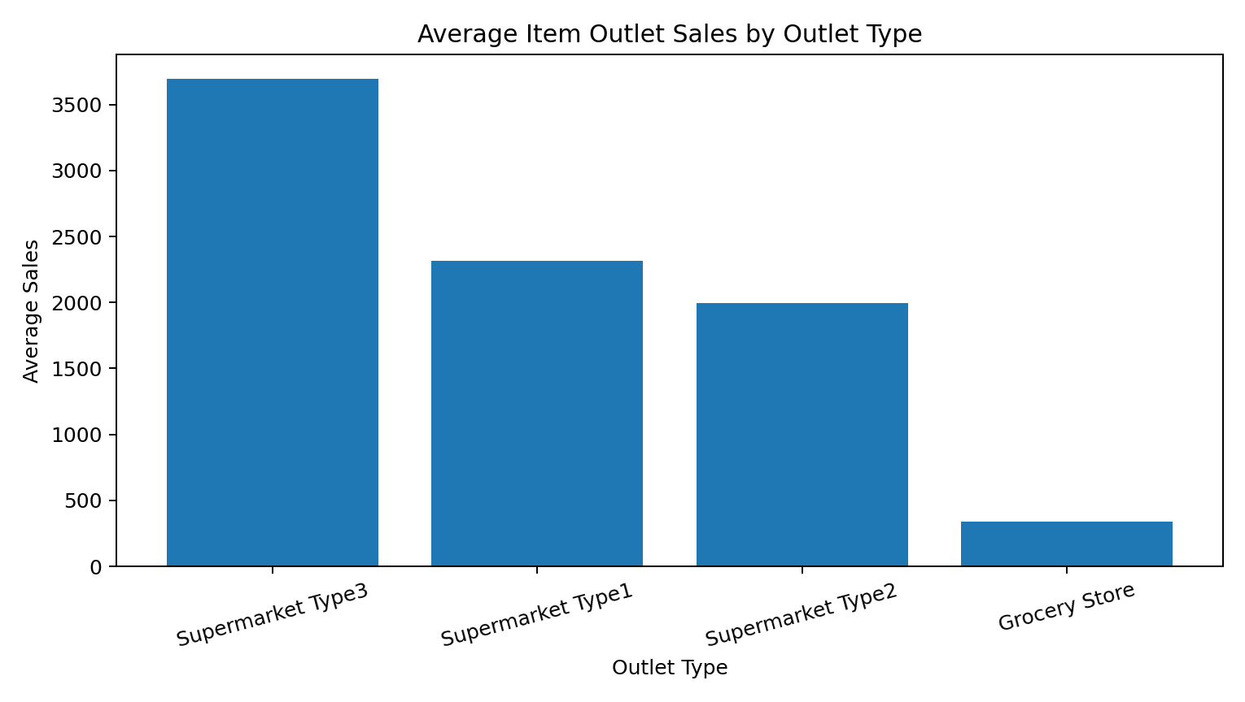
Average sales were compared across outlet types to see whether the type of outlet is related to different sales levels.
Key finding: Supermarket Type3 has the highest average sales, while Grocery Store has the lowest average sales in the analysis.

4. Correlations among the features
A correlation heatmap was used to see how the numerical features are related to each other and to sales.
In the heatmap:
• Positive value – both features tend to increase together.
• Negative value – one feature tends to increase while the other decreases.
• Value near zero – there is little linear relationship.
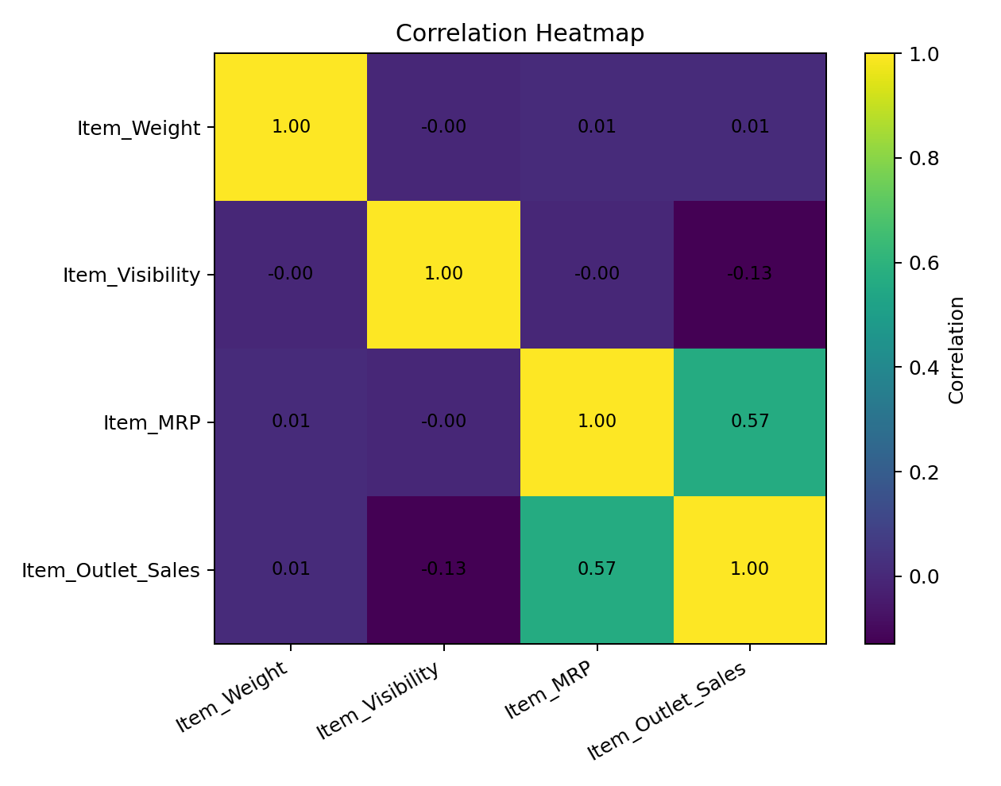
Key finding: Item MRP has the strongest positive relationship with Item Outlet Sales among the main numerical features.

5. Item MRP and Item Outlet Sales
A scatter plot was used in the notebook to compare Item MRP with Item Outlet Sales. This helps us see whether changes in MRP are associated with changes in sales.
Key finding: Item MRP shows a clear positive relationship with sales and is therefore useful for sales prediction.
6. Model Used – Random Forest Regressor
Random Forest Regressor was used because Item Outlet Sales is a continuous numerical value, so this is a regression problem.
- 80% of the labelled data was used for training and 20% for testing.
- One-Hot Encoding was used for categorical columns.
- Random Forest combines many decision trees to make predictions.
- The model used 300 trees with random_state = 42.
7. Model Evaluation
- Since this is a regression problem, accuracy is not the correct metric. The model was evaluated using MAE, RMSE and R².
- MAE – average prediction error; lower is better.
- RMSE – gives more importance to larger errors; lower is better.
- R² – shows how much variation in sales is explained by the model; higher is better.
The exact values are taken directly from the notebook after running the model.

Conclusion:
- The analysis shows that both product and outlet characteristics are related to Big Mart sales. Item MRP has a strong positive relationship with sales, and outlet type shows clear differences in average sales.
- The Random Forest Regressor uses these features together to predict Item Outlet Sales. The model can help Big Mart with inventory planning, product planning and outlet-level sales decisions.

